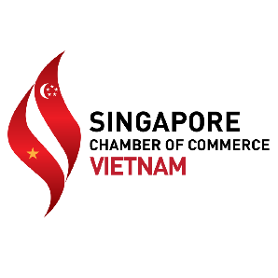

PARTICIPATION FORM

We wish to participate in The Reunion Dinner 2023 with the following packages:

Categories | Benefits & Entitlements
 | Dining Table for 10 people | Promotion Table | Logo on Backdrop & Ticket | Logo on Screen & E-flyer | Exclusive Benefit for SCCV Members
Table Sponsor  VND 22,000,000 | 1 TABLE with COMPANY LOGO | 10% Discount When Booking |  |  | 01 Complimentary EDM
Promotion Table Sponsor  VND 6,000,000 |  | 1 TABLE  with COMPANY LOGO & 1 STANDEE
Loose Ticket:  Adult: VND 2,200,000  Kid (4-12 years old):  VND 1,100,000 | N/A
Total Number of booking:  Dining Table  Promotion Table  Loose Ticket | Total Cost:

*A surcharge of 50% will be applied for any cancellations made after this booking form is received.

A. COMPANY DETAILS
1. Company Name:
2. Address:
3. Email:
4. Contact person:
5. Contact number:

B. PAYMENT METHOD

In cash at SCCV Office: 6/F, 115 - 115A Vo Van Tan Street, Vo Thi Sau Ward, District 3, HCMC
By wire transfer to SCCV bank account with details as follows:
- BANK – United Overseas Bank HCMC Branch or UOB Vietnam Limited (17 Le Duan Blvd., Dist. 1, HCMC)
- PAY TO – Singapore Business Group
- In VND – Account Number – 102 330 6218
- SWIFT code – UOVBVNVX
Others – Please specify:

Confirmed by (company’s stamp is required)

Signature: _________________________________________

Full name:
Position:
Date:

Please complete the info above and email the scanned copy of this completed form to SCCV Secretariat at sccv@singchamvn.org by 23rd December 2022.

For further assistance, please email or call us at 028 6685 5370/ 028 6685 5371.

Thank you for your generous support!

