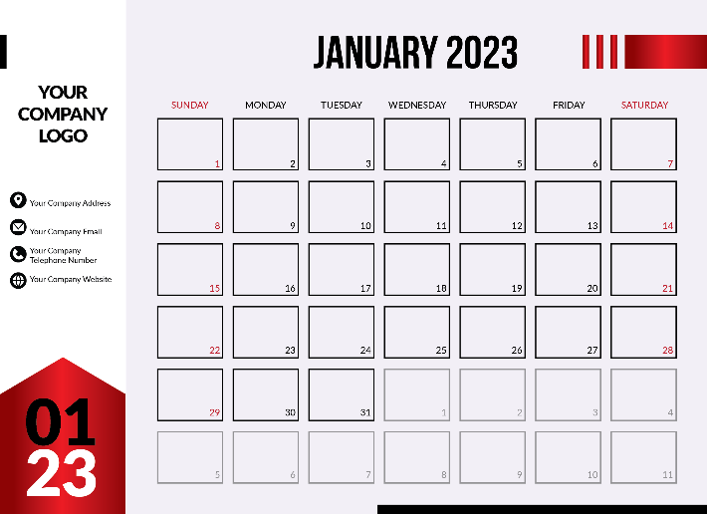
Calendar Page Photo Page
NO. | AD SLOT | QUANTITY | RATES  (VND/Unit) | BENEFITS PACKAGE
1 | Photo Page (ROP)* |  | SCCV Member:  VND 4,000,000 | - One (01) company logo  - Twenty (20) copies of printed Calendar
 | Calendar Page (ROP)* |  | SCCV Member:  VND 5,000,000 | - One (01) company logo  - Twenty (20) copies of printed Calendar  - One (01) company contact information**  - One (01) company QR code***
SPECIAL EARLY-BIRD OFFER: (for booking and settling payment by 18 Nov 2022):
- Free-of-charge for the page selection
- One (01) Company logo on Calendar Holding Bag
- One (01) Virtual Calendar on SCCV Website
*ROP: Run of Page indicates the sole right of the editorial board to insert the advertisement in any page without consulting the advertisers.
**Company contact information include: One (1) address, One (1) email, One (1) phone number, One (1) website.
***Company QR code: will be placed under company contact information.
2 | Request for specific advert positions (Optional):  + 1.000.000 VND/position for page selection  + 500.000 VND for Company Establishment Date printed on SCCV calendar
MONTH | PAGE | DATE
January
February
March
April
May
June
July
August
September
October
November
December

Total cost of Advertising

- All rates are in VND and is VAT exclusive.
- SCCV as a non-profit organization does not issue VAT invoice.
- Advertising bookings will be subject to availability and at the sole discretion of SCCV.
- Please be noted that advertiser is responsible for their own QR code design, company logo and company contact information. SCCV will only publish the original files received from advertiser. Furthermore, the files also need to be submitted following SCCV’s deadline and we will not refund if you are being late for the printing due date.

COMPANY INFORMATION (Click the grey blank to fill in your company details)
Company:
Address:
Contact Person’s Name: Email:
Contacted Mobile Phone Number:

PAYMENT DETAILS
- Payment is to be made within FIVE (05) working days after the confirmation.
- Cancellations after the confirmation will occur a surcharge of 50% of the booked ad slot rate.

Payment can be made either by cash in our office: Floor 6, Minh Tinh Building, 115-115A Vo Van Tan Street, Vo Thi Sau Ward, District 3, Ho Chi Minh City, or by bank transfer to our bank as follows:

BANK- UOB Vietnam Ltd (17 Le Duan Blvd., Dist 1, HCMC)
PAY TO - Singapore Business Group
In VND- Account Number – 102 330 6218
SWIFT code - UOVBVNVX

If payment is made by Bank Transfer, please email to us a scanned copy of the Transfer Voucher and we will issue you an official receipt for the paid amount. This is also to help us to check with the Bank to avoid any miscommunications.

Booking confirmed by (Please SIGN and STAMP in the blank below)
Full name: Designation:
Date:

Please send us your completed booking confirmation via email sccv@singchamvn.org or to SCCV Office at Floor 6, Minh Tinh Building, 115-115A Vo Van Tan Street, Vo Thi Sau Ward, District 3, Ho Chi Minh City.

More information, please contact us at +84 28 6685 5370/ +84 28 6685 5371. Thank you for advertising with SCCV!

